How to Change/Reset a Carrier User password
This is to be used to Change/Reset the password for a Carrier User.
This is self-service, to be done by the user.
Step 1 : Go to the NEXTrack log in page.
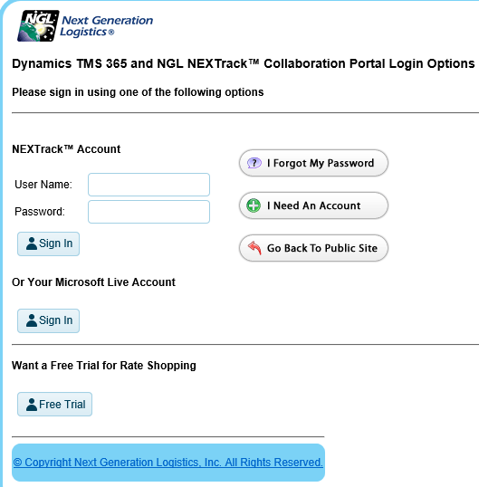

Reset a forgotten Carrier User password
Step 2 : Click on I forgot my password
Step 3 : On the next page, fill in your username and click on Send My Password.
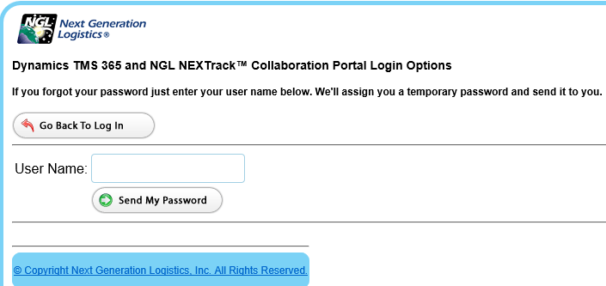
Step 4 : Click on Go Back To Log In and wait for your new password to be emailed to you.
This will typically take up to 15 minutes.
Step 5 : Using your username and new password, log in normally.

Change a Carrier User password
Step 2 : Using your username and current password, log in to NEXTrack.
Step 3 : If you are not taken to the home tab, click on home.
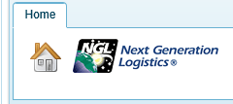
Step 4 : On the right top, click on the settings gear located between the sign out button and the help button.

Step 5 : The Manage My Account screen will open. Here you can change your profile info as well as change your password. Make sure to hit Save for profile changes, and Change password for password change.
